Online Appendix to:

**Political Ideology and Attitudinal Ambivalence: Investigating the Role of Ideological Extremity**

Content

**1. Supplementary Materials to Study 1** 3

1.1 Regression Models Predicting Ambivalence from Symbolic Ideology (Table A1) 3

1.2 Correlations of the social and the economic ideology dimension with ambivalence (Table A2) 4

1.3 Two-lines tests for the associations of social and economic ideology with ambivalence toward Merkel (Figures A1 and A2) 5

1.4 Two-lines tests for the associations of social and economic ideology with ambivalence toward Schulz (Figures A3 and A4) 7

**2. Supplementary Materials to Study 2** 9

2.1 Regression Models Predicting Ambivalence from Symbolic Ideology (Tables A3 to A5) 9

2.2 Two-lines tests for the associations of symbolic ideology with affective and cognitive ambivalence toward Scholz (Figures A5 and A6) 12

2.3 Two-lines tests for the associations of symbolic ideology with affective and cognitive ambivalence toward Laschet (Figures A7 and A8) 14

2.4 Two-lines tests for the associations of symbolic ideology with affective and cognitive ambivalence toward Baerbock (Figures A9 and A10) 16

**3. Supplementary Materials to Study 3** 18

3.1 Regression Models Predicting Ambivalence from Symbolic Ideology (Table A6) 18

3.2 Two-lines tests for the associations of symbolic ideology with affective ambivalence toward the different political parties (Figures A11 to A15) 19

3.3 Correlations of symbolic ideology with the residual ambivalence toward political parties not explained by general attitudes (Table A7) 24

3.4 Correlations of the social and the economic ideology dimension with ambivalence (Table A8) 25

3.5 Two-lines tests for the associations of social and economic ideology with affective ambivalence toward the political parties (Figures A11 to A15) 27

**4. References** 37

# **1. Supplementary Materials to Study 1**

## **1.1 Regression Models Predicting Ambivalence from Symbolic Ideology (Table A1)**

**Table A1**

*Regression Models Predicting Ambivalence from Symbolic Ideology*

|  |  |  |  |  |  |  |  |  |
| --- | --- | --- | --- | --- | --- | --- | --- | --- |
|  | **Merkel (1)** | | **Merkel (2)** | | **Schulz (1)** | | **Schulz (2)** | |
| *Predictors* | *Estimates* | *p* | *Estimates* | *p* | *Estimates* | *p* | *Estimates* | *p* |
| Political Ideology | -0.10 | **<0.001** | -0.11 | **<0.001** | -0.09 | **<0.001** | -0.10 | **<0.001** |
| Gender (1 = female) |  |  | -0.01 | **0.004** |  |  | -0.00 | 0.716 |
| Age |  |  | -0.00 | **<0.001** |  |  | -0.00 | **<0.001** |
| Education (1 = medium) |  |  | 0.03 | **<0.001** |  |  | 0.01 | 0.176 |
| Education (1 = high) |  |  | 0.04 | **<0.001** |  |  | 0.01 | 0.144 |
| Region (1 = Western Germany) |  |  | 0.01 | 0.152 |  |  | 0.01 | **0.001** |
| Political Interest |  |  | -0.10 | **<0.001** |  |  | -0.10 | **<0.001** |
| Observations | 13808 | | 13534 | | 13678 | | 13408 | |
| R2 / R2 adjusted | 0.008 / 0.008 | | 0.033 / 0.032 | | 0.008 / 0.007 | | 0.035 / 0.035 | |

*Note.* Ambivalence scores, political ideology, and political interest were scaled from 0 to 1. Regression tables were created using the *sjPlot* package for *R* (Lüdecke, 2021).

## **1.2** **Correlations of the social and the economic ideology dimension with ambivalence (Table A2)**

**Table A2**

*Correlations of the social and the economic ideology dimension with ambivalence*

|  |  |  |  |  |  |  |
| --- | --- | --- | --- | --- | --- | --- |
| Variable | *M* | *SD* | 1 | 2 | 3 | 4 |
|  |  |  |  |  |  |  |
| 1. Symbolic ideology | 5.62 | 2.08 |  |  |  |  |
|  |  |  |  |  |  |  |
| 2. Economic ideology | 3.87 | 1.39 | .30** |  |  |  |
|  |  |  | [.29, .32] |  |  |  |
|  |  |  |  |  |  |  |
| 3. Social ideology | 5.13 | 1.67 | .42** | .24** |  |  |
|  |  |  | [.41, .43] | [.22, .25] |  |  |
|  |  |  |  |  |  |  |
| 4. Ambivalence toward Merkel | 0.96 | 1.41 | -.09** | -.02 | -.16** |  |
|  |  |  | [-.11, -.07] | [-.03, .00] | [-.17, -.14] |  |
|  |  |  |  |  |  |  |
| 5. Ambivalence toward Schulz | 1.06 | 1.30 | -.09** | -.03** | -.13** | .47** |
|  |  |  | [-.10, -.07] | [-.05, -.02] | [-.15, -.11] | [.46, .48] |
|  |  |  |  |  |  |  |

Note. Opposition to immigration, which was measured on a scale ranging from 1 (*immigration for foreigners should be easier*) to 7 (*immigration for foreigners should be more difficult*) was used as an indicator of social ideology. Attitudes toward taxes and social benefits, which were measured on a scale originally ranging from 1 (*lower taxes, although this results in less social services*) to 7 (*more social services, although this results in raising taxes*) [recoded for the present analyses] was used as an indicator of economic ideology. Correllation ables were created using the *apaTables* package for R (Stanley, 2021). * indicates p < .05. ** indicates p < .01.

Comparing some of the correlations of Table A2 using the *cocor* package for *R* (Diedenhofen & Musch, 2015) reveals that ambivalence toward Merkel is correlated significantly more strongly with social ideology than with economic ideology, z = -13.84, p < .0001. Similarly, ambivalence toward Schulz is correlated significantly more strongly with social ideology than with economic ideology, z = -9.39, p < .0001. In addition, the correlation of ambivalence toward Merkel with symbolic ideology is weaker than its correlation with social ideology, z = -7.33, p < .0001, and stronger than its correlation with economic ideology, z = 7.10, p < .0001. similarly, the correlation of ambivalence toward Schulz with symbolic ideology is weaker than its correlation with social ideology, z = -5.08, p < .0001, and stronger than its correlation with economic ideology, z = 4.76, p < .0001.

## **1.3 Two-lines tests for the associations of social and economic ideology with ambivalence toward Merkel (Figures A1 and A2)**

**Figure A1**

*The association of affective ambivalence and the general attitude toward Angela Merkel with opposition to immigration*

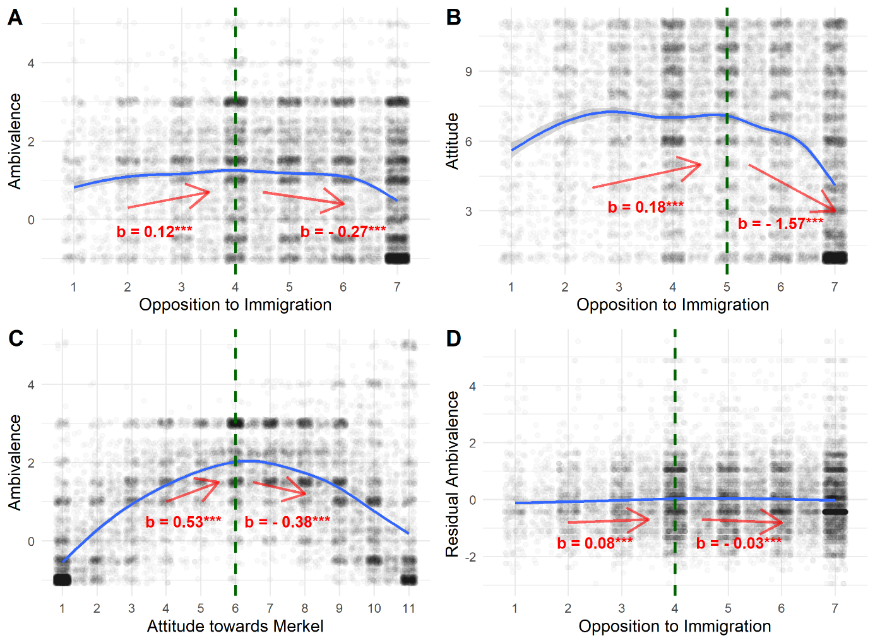

*Note.* The dashed vertical line represents the break point and the arrows and regression weights, refer to the regression lines below and above the break point of a two-lines test according to the algorithm developed by Simonsohn (2018). *** indicates p < .0001, ** indicates p < .001, * indicates p < .05.

**Figure A2**

*The association of affective ambivalence and the general attitude toward Angela Merkel with economic ideology*

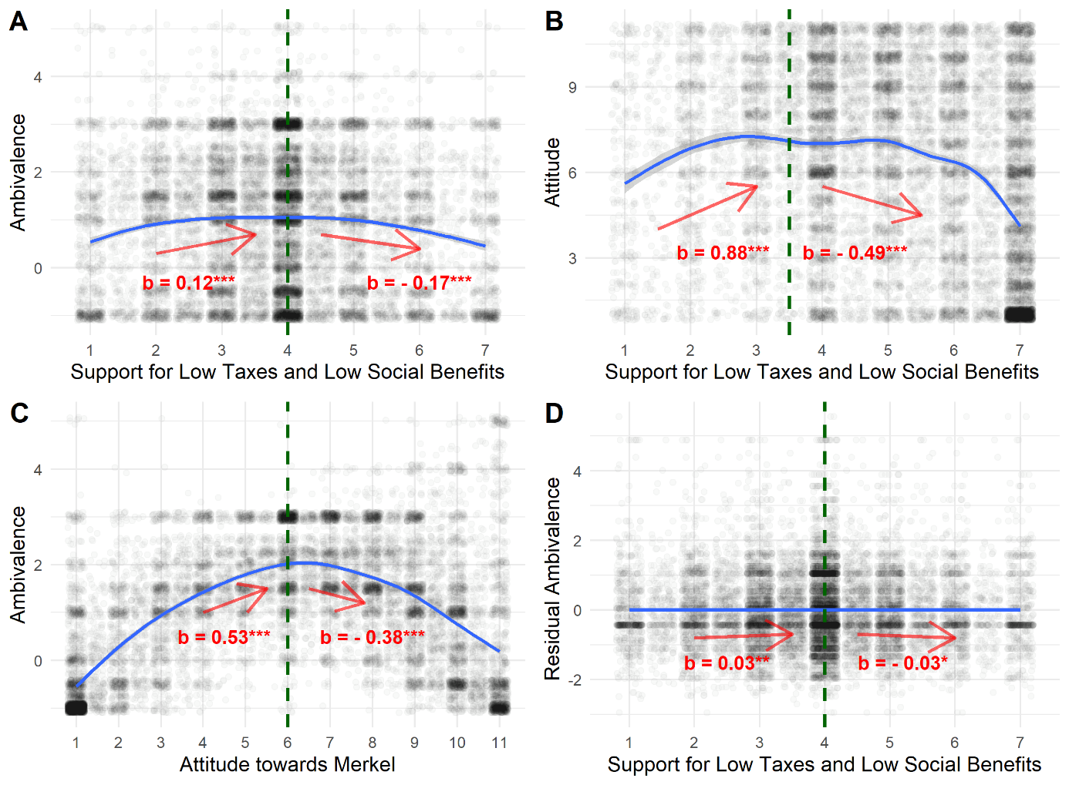

*Note.* The dashed vertical line represents the break point and the arrows and regression weights, refer to the regression lines below and above the break point of a two-lines test according to the algorithm developed by Simonsohn (2018). *** indicates p < .0001, ** indicates p < .001, * indicates p < .05.

## **1.4 Two-lines tests for the associations of social and economic ideology with ambivalence toward Schulz (Figures A3 and A4)**

**Figure A3**

*The association of affective ambivalence and the general attitude toward Martin Schulz with opposition to immigration*

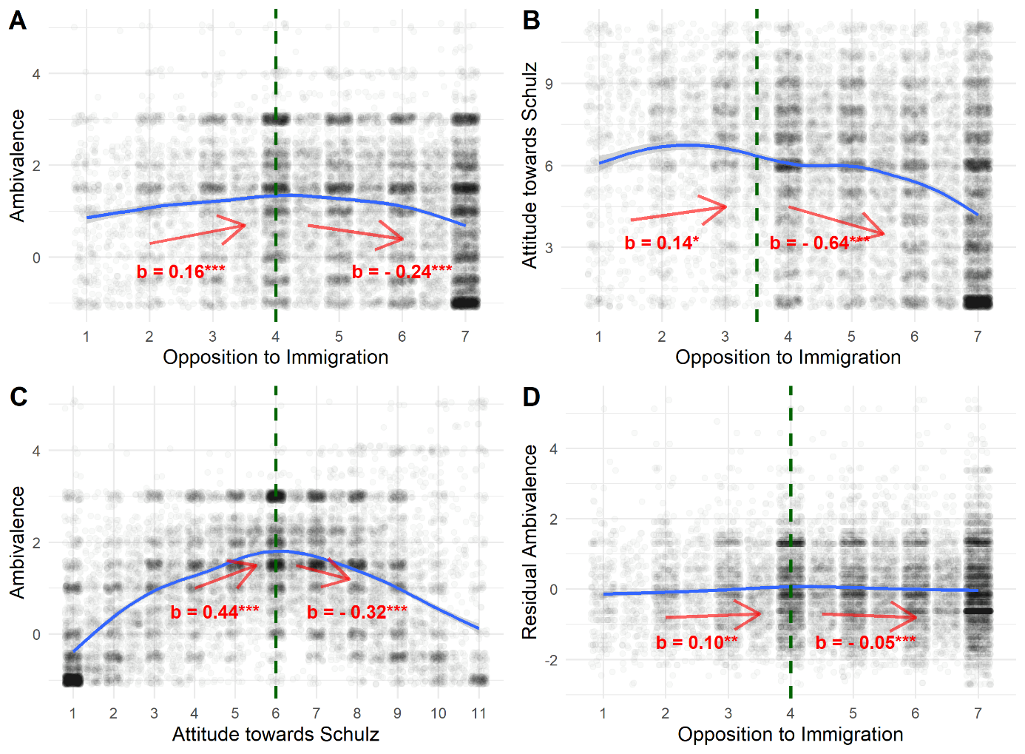

*Note.* The dashed vertical line represents the break point and the arrows and regression weights, refer to the regression lines below and above the break point of a two-lines test according to the algorithm developed by Simonsohn (2018). *** indicates p < .0001, ** indicates p < .001, * indicates p < .05.

**Figure A4**

*The association of affective ambivalence and the general attitude toward Martin Schulz with economic ideology*

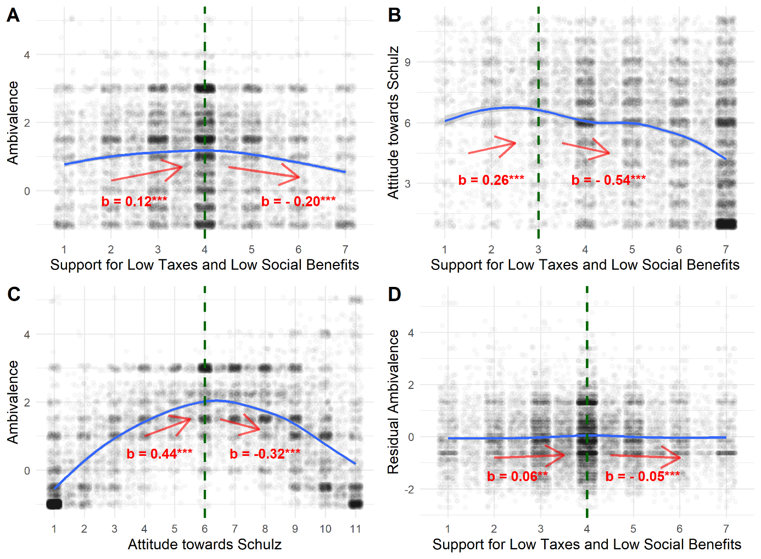

*Note.* The dashed vertical line represents the break point and the arrows and regression weights, refer to the regression lines below and above the break point of a two-lines test according to the algorithm developed by Simonsohn (2018). *** indicates p < .0001, ** indicates p < .001, * indicates p < .05.

# **2. Supplementary Materials to Study 2**

## **2.1 Regression Models Predicting Ambivalence from Symbolic Ideology (Tables A3 to A5)**

**Table A3**

*Regression Models Predicting Ambivalence toward Olaf Scholz from Symbolic Ideology*

|  |  |  |  |  |  |  |  |  |
| --- | --- | --- | --- | --- | --- | --- | --- | --- |
|  | **Affective Ambivalence (1)** | | **Affective Ambivalence (2)** | | **Cognitive Ambivalence (1)** | | **Cognitive Ambivalence (2)** | |
| *Predictors* | *Estimates* | *p* | *Estimates* | *p* | *Estimates* | *p* | *Estimates* | *p* |
| Political Ideology | 0.04 | **0.006** | 0.04 | **0.006** | 0.02 | 0.237 | 0.02 | 0.104 |
| Gender (1 = female) |  |  | -0.00 | 0.525 |  |  | 0.01 | **0.012** |
| Age |  |  | -0.00 | **<0.001** |  |  | -0.00 | **<0.001** |
| Education (1 = medium) |  |  | 0.01 | 0.278 |  |  | 0.02 | 0.061 |
| Education (1 = high) |  |  | 0.02 | 0.115 |  |  | 0.02 | **0.034** |
| Region (1 = Western Germany) |  |  | 0.00 | 0.610 |  |  | 0.02 | **<0.001** |
| Political Interest |  |  | -0.06 | **<0.001** |  |  | -0.03 | **0.027** |
| Observations | 6526 | | 6451 | | 6472 | | 6399 | |
| R2 / R2 adjusted | 0.001 / 0.001 | | 0.010 / 0.009 | | 0.000 / 0.000 | | 0.013 / 0.011 | |

*Note*. Ambivalence scores, political ideology, and political interest were scaled from 0 to 1.

**Table A4**

*Regression Models Predicting Ambivalence toward Armin Laschet from Symbolic Ideology*

|  |  |  |  |  |  |  |  |  |
| --- | --- | --- | --- | --- | --- | --- | --- | --- |
|  | **Affective Ambivalence (1)** | | **Affective Ambivalence (2)** | | **Cognitive Ambivalence (1)** | | **Cognitive Ambivalence (2)** | |
| *Predictors* | *Estimates* | *p* | *Estimates* | *p* | *Estimates* | *p* | *Estimates* | *p* |
| Political Ideology | 0.09 | **<0.001** | 0.08 | **<0.001** | 0.10 | **<0.001** | 0.09 | **<0.001** |
| Gender (1 = female) |  |  | -0.01 | 0.113 |  |  | -0.00 | 0.515 |
| Age |  |  | 0.00 | **<0.001** |  |  | 0.00 | **<0.001** |
| Education (1 = medium) |  |  | 0.01 | 0.526 |  |  | 0.01 | 0.348 |
| Education (1 = high) |  |  | 0.01 | 0.156 |  |  | 0.02 | **0.035** |
| Region (1 = Western Germany) |  |  | -0.01 | 0.263 |  |  | 0.00 | 0.479 |
| Political Interest |  |  | -0.10 | **<0.001** |  |  | -0.09 | **<0.001** |
| Observations | 6493 | | 6418 | | 6370 | | 6300 | |
| R2 / R2 adjusted | 0.007 / 0.007 | | 0.023 / 0.022 | | 0.008 / 0.007 | | 0.015 / 0.014 | |

*Note.* Ambivalence scores, political ideology, and political interest were scaled from 0 to 1.

**Table A5**

*Regression Models Predicting Ambivalence toward Annalena Baerbock from Symbolic Ideology*

|  |  |  |  |  |  |  |  |  |
| --- | --- | --- | --- | --- | --- | --- | --- | --- |
|  | **Affective Ambivalence (1)** | | **Affective Ambivalence (2)** | | **Cognitive Ambivalence (1)** | | **Cognitive Ambivalence (2)** | |
| *Predictors* | *Estimates* | *p* | *Estimates* | *p* | *Estimates* | *p* | *Estimates* | *p* |
| Political Ideology | -0.09 | **<0.001** | -0.10 | **<0.001** | -0.21 | **<0.001** | -0.21 | **<0.001** |
| Gender (1 = female) |  |  | -0.00 | 0.502 |  |  | 0.02 | **0.014** |
| Age |  |  | 0.00 | **<0.001** |  |  | -0.00 | **0.013** |
| Education (1 = medium) |  |  | -0.01 | 0.329 |  |  | 0.00 | 0.867 |
| Education (1 = high) |  |  | -0.02 | 0.118 |  |  | 0.03 | **0.017** |
| Region (1 = Western Germany) |  |  | 0.02 | **0.007** |  |  | 0.05 | **<0.001** |
| Political Interest |  |  | -0.05 | **<0.001** |  |  | -0.04 | **0.002** |
| Observations | 6528 | | 6452 | | 6416 | | 6344 | |
| R2 / R2 adjusted | 0.006 / 0.006 | | 0.014 / 0.013 | | 0.034 / 0.033 | | 0.045 / 0.044 | |

*Note.* Ambivalence scores, political ideology, and political interest were scaled from 0 to 1.

## **2.2 Two-lines tests for the associations of symbolic ideology with affective and cognitive ambivalence toward Scholz (Figures A5 and A6)**

**Figure A5**

*The association of affective ambivalence and the general attitude toward Olaf Scholz with symbolic ideology*

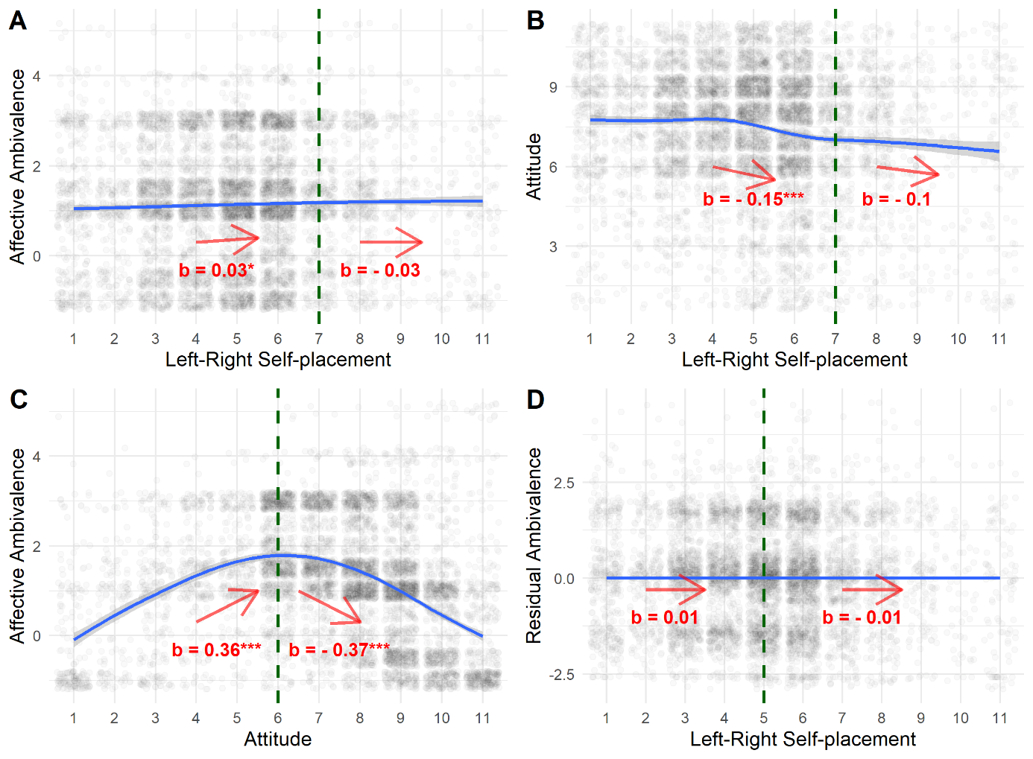

*Note.* The dashed vertical line represents the break point and the arrows and regression weights, refer to the regression lines below and above the break point of a two-lines test according to the algorithm developed by Simonsohn (2018). *** indicates p < .0001, ** indicates p < .001, * indicates p < .05.

***Figure A6***

*The association of cognitive ambivalence and the general attitude toward Olaf Scholz with symbolic ideology*

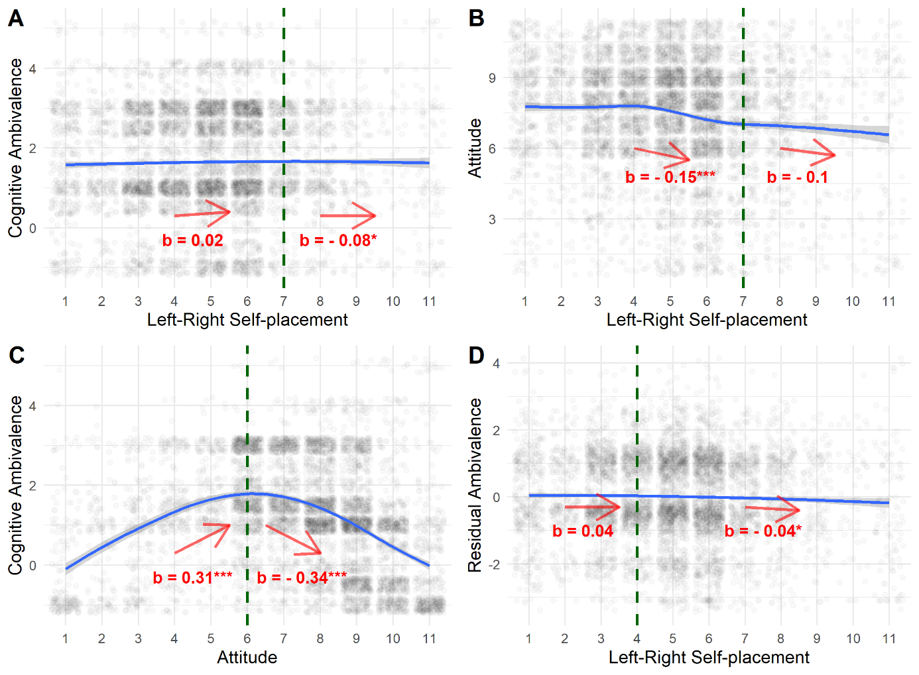

*Note.* The dashed vertical line represents the break point and the arrows and regression weights, refer to the regression lines below and above the break point of a two-lines test according to the algorithm developed by Simonsohn (2018). *** indicates p < .0001, ** indicates p < .001, * indicates p < .05.

## **2.3 Two-lines tests for the associations of symbolic ideology with affective and cognitive ambivalence toward Laschet (Figures A7 and A8)**

**Figure A7**

*The association of affective ambivalence and the general attitude toward Armin Laschet with symbolic ideology*

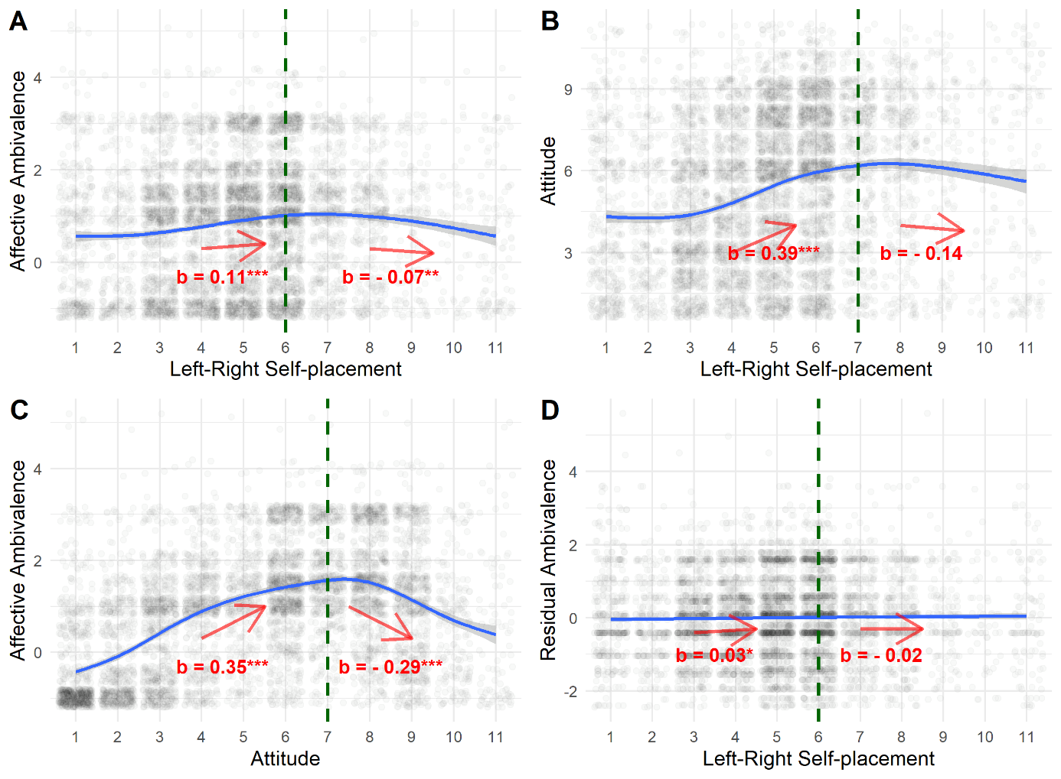

*Note.* The dashed vertical line represents the break point and the arrows and regression weights, refer to the regression lines below and above the break point of a two-lines test according to the algorithm developed by Simonsohn (2018). *** indicates p < .0001, ** indicates p < .001, * indicates p < .05.

**Figure A8**

*The association of cognitive ambivalence and the general attitude toward Armin Laschet with symbolic ideology*

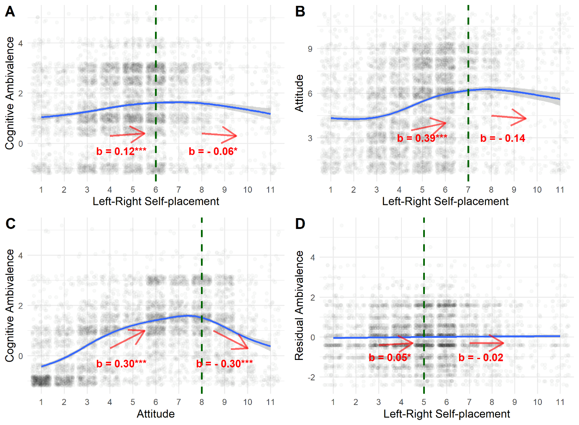

*Note.* The dashed vertical line represents the break point and the arrows and regression weights, refer to the regression lines below and above the break point of a two-lines test according to the algorithm developed by Simonsohn (2018). *** indicates p < .0001, ** indicates p < .001, * indicates p < .05.

## **2.4 Two-lines tests for the associations of symbolic ideology with affective and cognitive ambivalence toward Baerbock (Figures A9 and A10)**

**Figure A9**

*The association of affective ambivalence and the general attitude toward Annalena Baerbock with symbolic ideology*

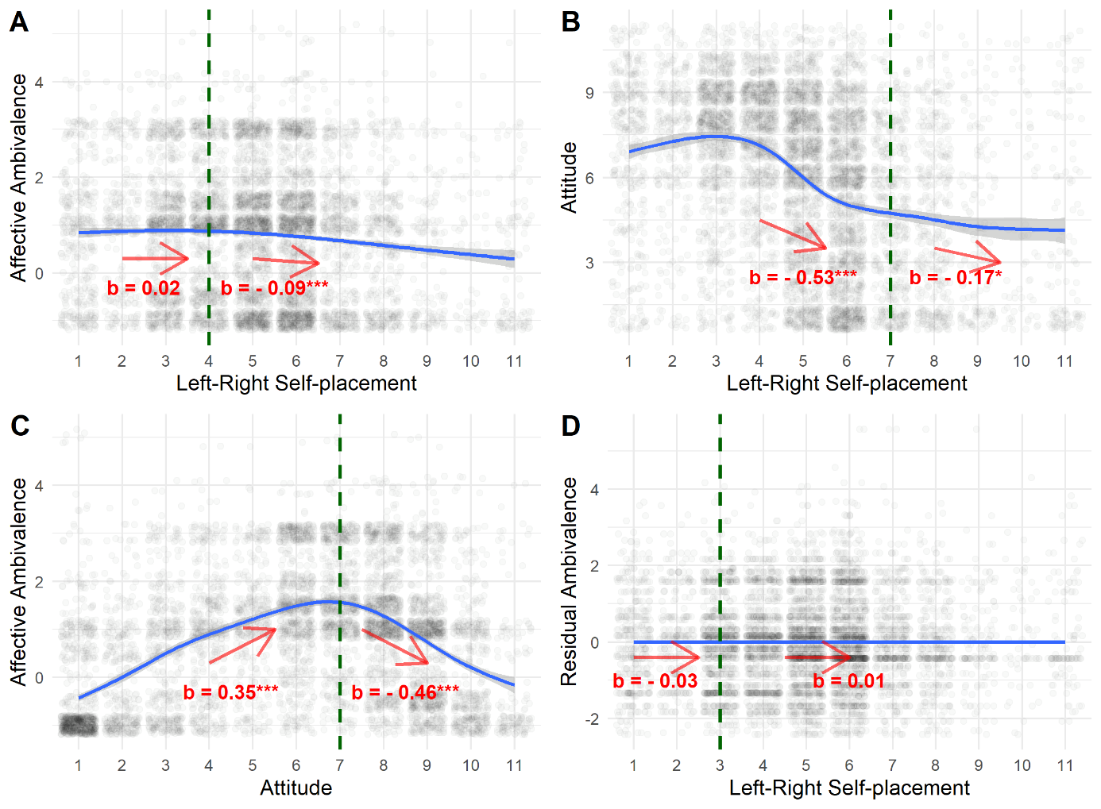

*Note.* The dashed vertical line represents the break point and the arrows and regression weights, refer to the regression lines below and above the break point of a two-lines test according to the algorithm developed by Simonsohn (2018). *** indicates p < .0001, ** indicates p < .001, * indicates p < .05.

**Figure A10**

*The association of cognitive ambivalence and the general attitude toward Annalena Baerbock with symbolic ideology*

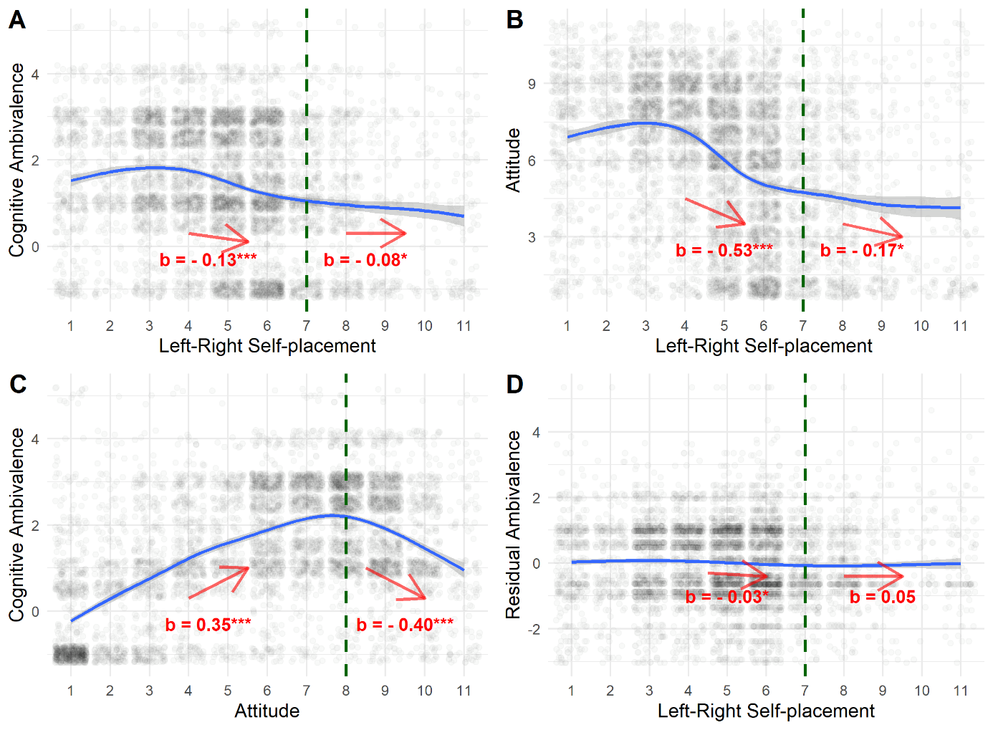

*Note.* The dashed vertical line represents the break point and the arrows and regression weights, refer to the regression lines below and above the break point of a two-lines test according to the algorithm developed by Simonsohn (2018). *** indicates p < .0001, ** indicates p < .001, * indicates p < .05.

# **3. Supplementary Materials to Study 3**

## **3.1 Regression Models Predicting Ambivalence from Symbolic Ideology (Table A6)**

**Table A6**

*Regression Models Predicting Ambivalence toward the different political parties from Symbolic Ideology*

|  |  |  |  |  |  |  |  |  |  |  |  |  |  |  |  |  |  |  |  |  |
| --- | --- | --- | --- | --- | --- | --- | --- | --- | --- | --- | --- | --- | --- | --- | --- | --- | --- | --- | --- | --- |
|  | **CDU (1)** | | **CDU (2)** | | **SPD (1)** | | **SPD (2)** | | **FDP (1)** | | **FDP (2)** | | **Green Party (1)** | | **Green Party (2)** | | **The LEFT (1)** | | **The LEFT (2)** | |
| *Predictors* | *Estimates* | *p* | *Estimates* | *p* | *Estimates* | *p* | *Estimates* | *p* | *Estimates* | *p* | *Estimates* | *p* | *Estimates* | *p* | *Estimates* | *p* | *Estimates* | *p* | *Estimates* | *p* |
| Political Ideology | 0.15 | **<0.001** | 0.14 | **<0.001** | 0.04 | **0.004** | 0.03 | **0.010** | 0.34 | **<0.001** | 0.32 | **<0.001** | -0.03 | **0.025** | -0.04 | **0.004** | -0.14 | **<0.001** | -0.16 | **<0.001** |
| Gender (1 = female) |  |  | 0.01 | 0.356 |  |  | 0.01 | **0.037** |  |  | 0.04 | **<0.001** |  |  | 0.03 | **<0.001** |  |  | 0.03 | **<0.001** |
| Age |  |  | -0.00 | **0.017** |  |  | -0.00 | **0.010** |  |  | -0.00 | **<0.001** |  |  | -0.00 | 0.158 |  |  | -0.00 | **<0.001** |
| Education (1 = medium) |  |  | 0.01 | 0.145 |  |  | 0.01 | 0.144 |  |  | -0.01 | 0.130 |  |  | -0.01 | 0.176 |  |  | -0.01 | 0.075 |
| Education (1 = high) |  |  | 0.02 | 0.055 |  |  | 0.03 | **<0.001** |  |  | -0.01 | 0.152 |  |  | -0.01 | 0.069 |  |  | -0.04 | **<0.001** |
| Region (1 = East Germany) |  |  | 0.03 | **<0.001** |  |  | 0.02 | **0.006** |  |  | 0.01 | 0.154 |  |  | 0.01 | 0.080 |  |  | 0.03 | **<0.001** |
| Political Interest |  |  | -0.11 | **<0.001** |  |  | -0.08 | **<0.001** |  |  | -0.13 | **<0.001** |  |  | -0.07 | **<0.001** |  |  | -0.08 | **<0.001** |
| Observations | 4789 | | 4788 | | 4786 | | 4785 | | 4781 | | 4780 | | 4785 | | 4784 | | 4784 | | 4783 | |
| R2 / R2 adjusted | 0.022 / 0.022 | | 0.045 / 0.044 | | 0.002 / 0.001 | | 0.022 / 0.021 | | 0.106 / 0.106 | | 0.153 / 0.152 | | 0.001 / 0.001 | | 0.019 / 0.017 | | 0.021 / 0.020 | | 0.059 / 0.058 | |

## **3.2 Two-lines tests for the associations of symbolic ideology with affective ambivalence toward the different political parties (Figures A11 to A15)**

**Figure A11**

*The association of affective ambivalence and the general attitude toward the CDU with symbolic ideology*

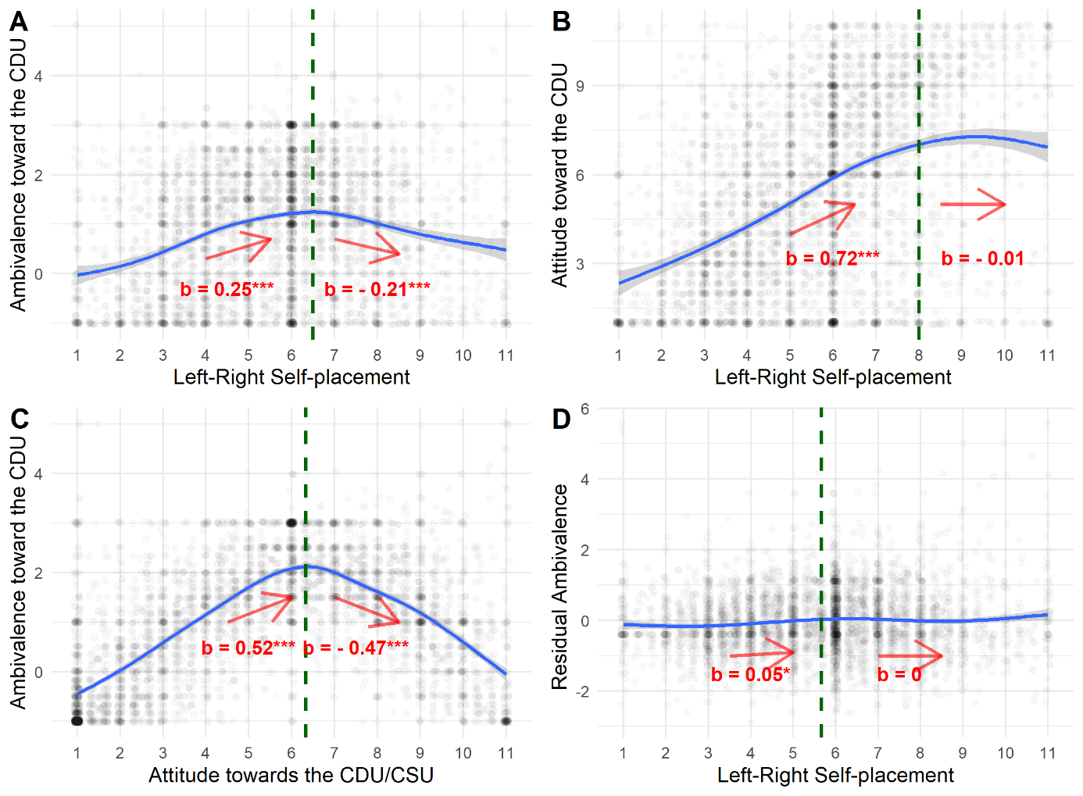

*Note.* The dashed vertical line represents the break point and the arrows and regression weights, refer to the regression lines below and above the break point of a two-lines test according to the algorithm developed by Simonsohn (2018). *** indicates p < .0001, ** indicates p < .001, * indicates p < .05.

**Figure A12**

*The association of affective ambivalence and the general attitude toward the SPD with symbolic ideology*

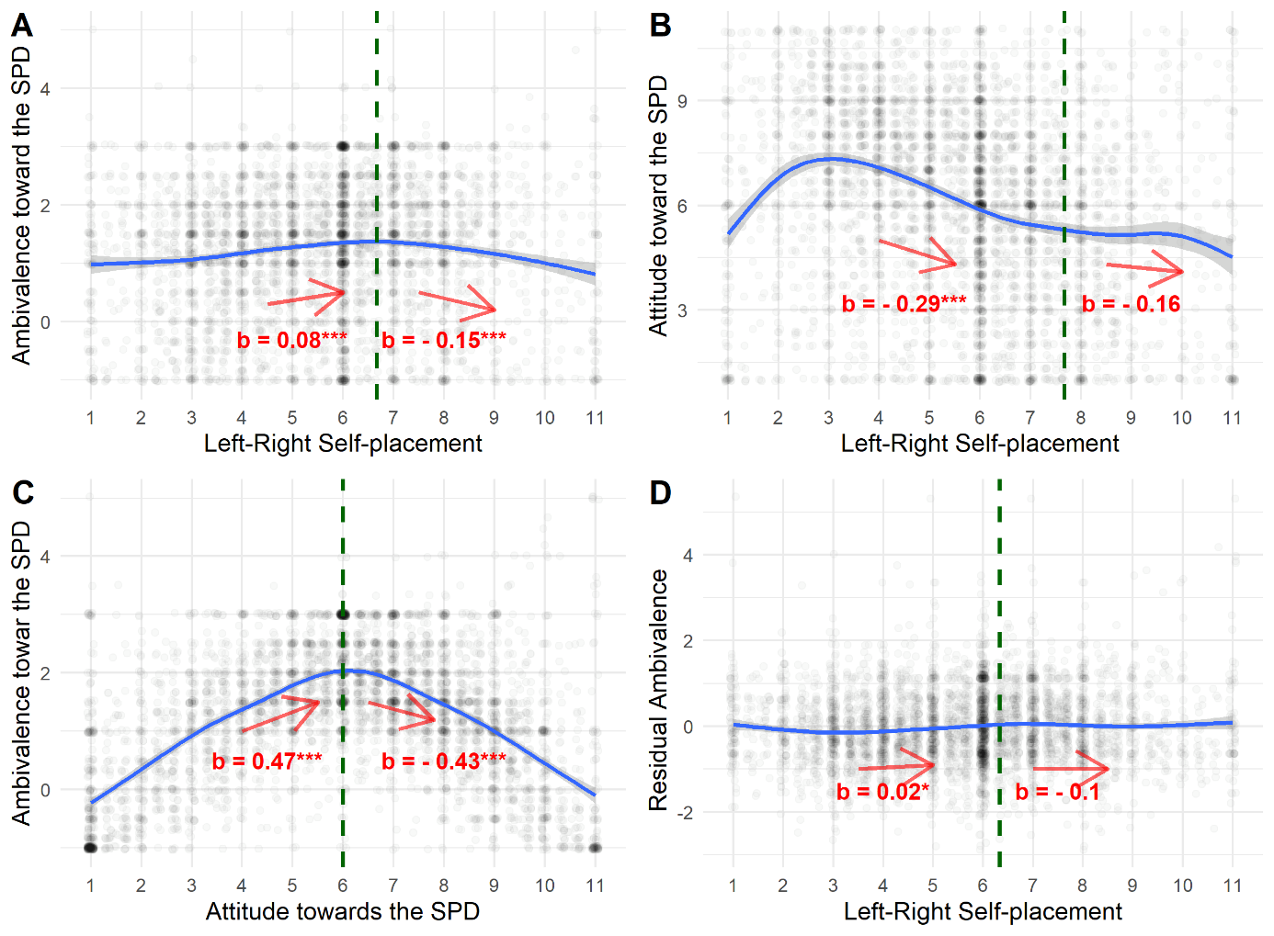

*Note.* The dashed vertical line represents the break point and the arrows and regression weights, refer to the regression lines below and above the break point of a two-lines test according to the algorithm developed by Simonsohn (2018). *** indicates p < .0001, ** indicates p < .001, * indicates p < .05.

**Figure A13**

*The association of affective ambivalence and the general attitude toward the FDP with symbolic ideology*

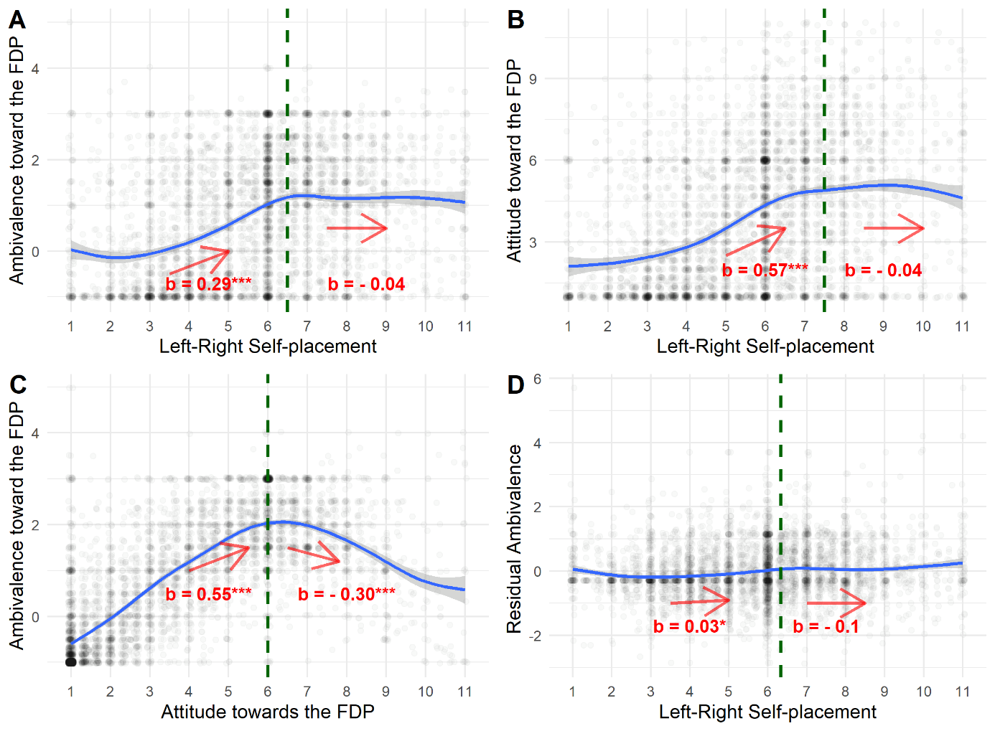

*Note.* The dashed vertical line represents the break point and the arrows and regression weights, refer to the regression lines below and above the break point of a two-lines test according to the algorithm developed by Simonsohn (2018). *** indicates p < .0001, ** indicates p < .001, * indicates p < .05.

**Figure A14**

*The association of affective ambivalence and the general attitude toward the GREEN party with symbolic ideology*

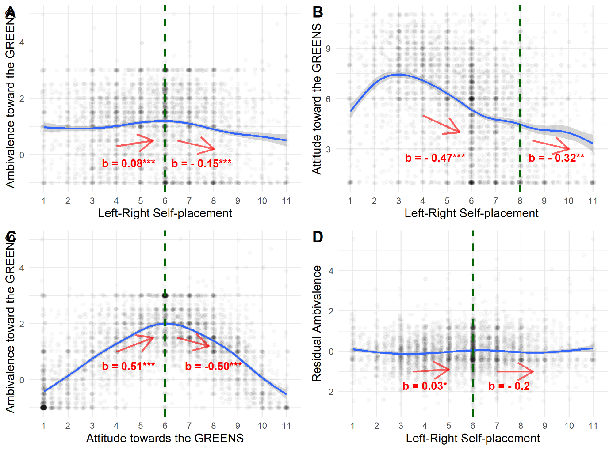

*Note.* The dashed vertical line represents the break point and the arrows and regression weights, refer to the regression lines below and above the break point of a two-lines test according to the algorithm developed by Simonsohn (2018). *** indicates p < .0001, ** indicates p < .001, * indicates p < .05.

**Figure A15**

*The association of affective ambivalence and the general attitude toward Die LINKE with symbolic ideology*

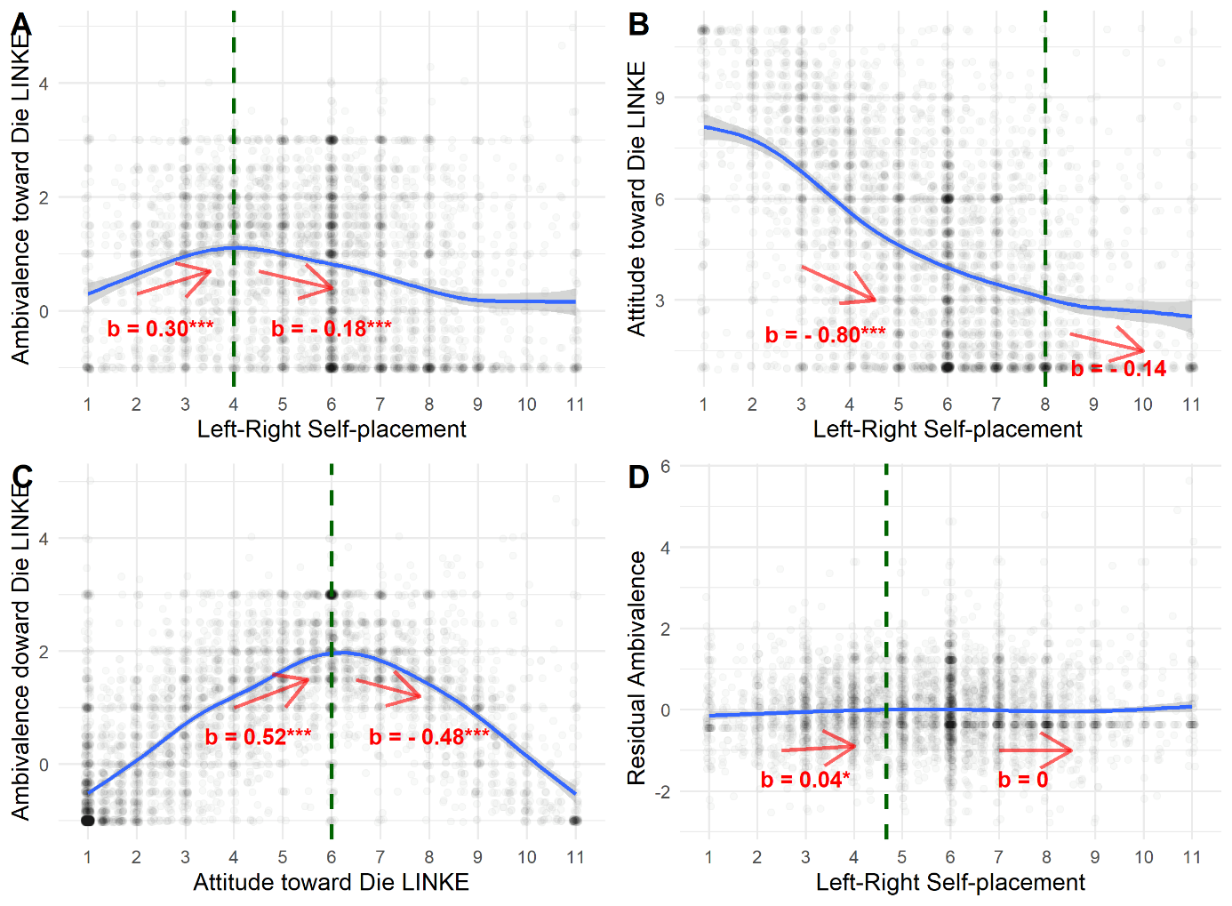

*Note.* The dashed vertical line represents the break point and the arrows and regression weights, refer to the regression lines below and above the break point of a two-lines test according to the algorithm developed by Simonsohn (2018). *** indicates p < .0001, ** indicates p < .001, * indicates p < .05.

## **3.3 Correlations of symbolic ideology with the residual ambivalence toward political parties not explained by general attitudes (Table A7)**

**Table A7**

*Correlations of symbolic ideology with the residual ambivalence toward political parties not explained by general attitudes*

|  |  |  |  |  |  |  |  |
| --- | --- | --- | --- | --- | --- | --- | --- |
| Variable | *M* | *SD* | 1 | 2 | 3 | 4 | 5 |
|  |  |  |  |  |  |  |  |
| 1. Symbolic ideology | 5.61 | 2.12 |  |  |  |  |  |
|  |  |  |  |  |  |  |  |
| 2. Ambivalence toward the CDU | 0.00 | 0.95 | .07** |  |  |  |  |
|  |  |  | [.04, .09] |  |  |  |  |
|  |  |  |  |  |  |  |  |
| 3. Ambivalence toward the SPD | 0.00 | 0.90 | .06** | .47** |  |  |  |
|  |  |  | [.03, .08] | [.45, .49] |  |  |  |
|  |  |  |  |  |  |  |  |
| 4. Ambivalence toward the FDP | -0.00 | 0.87 | .10** | .50** | .46** |  |  |
|  |  |  | [.07, .13] | [.47, .52] | [.44, .48] |  |  |
|  |  |  |  |  |  |  |  |
| 5. Ambivalence toward the Green party | -0.00 | 0.89 | .03* | .41** | .51** | .48** |  |
|  |  |  | [.00, .06] | [.39, .43] | [.49, .53] | [.46, .50] |  |
|  |  |  |  |  |  |  |  |
| 6. Ambivalence toward Die LINKE | -0.00 | 0.90 | .02 | .40** | .41** | .44** | .51** |
|  |  |  | [-.01, .05] | [.38, .42] | [.38, .43] | [.41, .46] | [.49, .53] |
|  |  |  |  |  |  |  |  |

*Note.* Values in square brackets indicate the 95% confidence interval for each correlation. * indicates *p* < .05. ** indicates *p* < .01.

## **3.4** **Correlations of the social and the economic ideology dimension with ambivalence (Table A8)**

**Table A8**

*Correlations of the social and the economic ideology dimension with ambivalence*

|  |  |  |  |  |  |  |  |  |  |
| --- | --- | --- | --- | --- | --- | --- | --- | --- | --- |
| Variable | *M* | *SD* | 1 | 2 | 3 | 4 | 5 | 6 | 7 |
|  |  |  |  |  |  |  |  |  |  |
| 1. Symbolic ideology | 5.61 | 2.12 |  |  |  |  |  |  |  |
|  |  |  |  |  |  |  |  |  |  |
| 2. Social ideology | 4.90 | 1.71 | .33** |  |  |  |  |  |  |
|  |  |  | [.30, .35] |  |  |  |  |  |  |
|  |  |  |  |  |  |  |  |  |  |
| 3. Economic ideology | 3.95 | 1.36 | .32** | .23** |  |  |  |  |  |
|  |  |  | [.29, .34] | [.20, .25] |  |  |  |  |  |
|  |  |  |  |  |  |  |  |  |  |
| 4. Amb. toward the CDU | 0.96 | 1.29 | .15** | .04** | .10** |  |  |  |  |
|  |  |  | [.12, .18] | [.01, .06] | [.07, .12] |  |  |  |  |
|  |  |  |  |  |  |  |  |  |  |
| 5. Amb. toward the SPD | 1.26 | 1.15 | .04** | -.02 | .03* | .44** |  |  |  |
|  |  |  | [.01, .07] | [-.05, .01] | [.00, .05] | [.42, .46] |  |  |  |
|  |  |  |  |  |  |  |  |  |  |
| 6. Amb. toward the FDP | 0.77 | 1.35 | .33** | .12** | .21** | .49** | .42** |  |  |
|  |  |  | [.30, .35] | [.09, .14] | [.18, .23] | [.47, .51] | [.40, .44] |  |  |
|  |  |  |  |  |  |  |  |  |  |
| 7. Amb. toward the Green party | 1.06 | 1.23 | -.03* | -.03* | -.04** | .34** | .49** | .37** |  |
|  |  |  | [-.06, -.00] | [-.06, -.00] | [-.06, -.01] | [.32, .37] | [.47, .51] | [.35, .40] |  |
|  |  |  |  |  |  |  |  |  |  |
| 8. Amb. toward Die LINKE | 0.78 | 1.29 | -.14** | -.03* | -.08** | .32** | .35** | .24** | .45** |
|  |  |  | [-.17, -.12] | [-.06, -.01] | [-.10, -.05] | [.30, .35] | [.32, .37] | [.22, .27] | [.43, .47] |
|  |  |  |  |  |  |  |  |  |  |

*Note.* Values in square brackets indicate the 95% confidence interval for each correlation. * indicates *p* < .05. ** indicates *p* < .01.

Comparing some of the correlations of Table A8 using the *cocor* package for R (Diedenhofen & Much, 2015) reveals that ambivalence toward the CDU is positively correlated more strongly with symbolic ideology than with economic ideology, z = -2.29, p = .02, which is correlated more strongly with ambivalence than social ideology, z = -3.50, p < .001. Ambivalence toward the SPD is negatively correlated with social ideology and positively correlated with symbolic and economic ideology, while the strength of the positive correlations does not differ significantly. Ambivalence toward the FDP correlates more strongly with symbolic ideology than with economic ideology, z = -6.26, p < .001, which correlates more strongly with ambivalence than social ideology, z = -5.41, p < .001. Ambivalence toward the Green party is negatively correlated with all ideology dimensions, which do not differ significantly in the size of their correlations. Ambivalence toward Die LINKE is negatively correlated with all ideology dimensions while the correlation with symbolic ideology is stronger than the correlation with economic ideology, z = 3.38, p < .001, which is stronger than the correlation with social ideology, z = 2.50, p =.01.

## **3.5 Two-lines tests for the associations of social and economic ideology with affective ambivalence toward the political parties (Figures A11 to A15)**

**Figure A16**

*The association of affective ambivalence and the general attitude toward the CDU with social ideology*

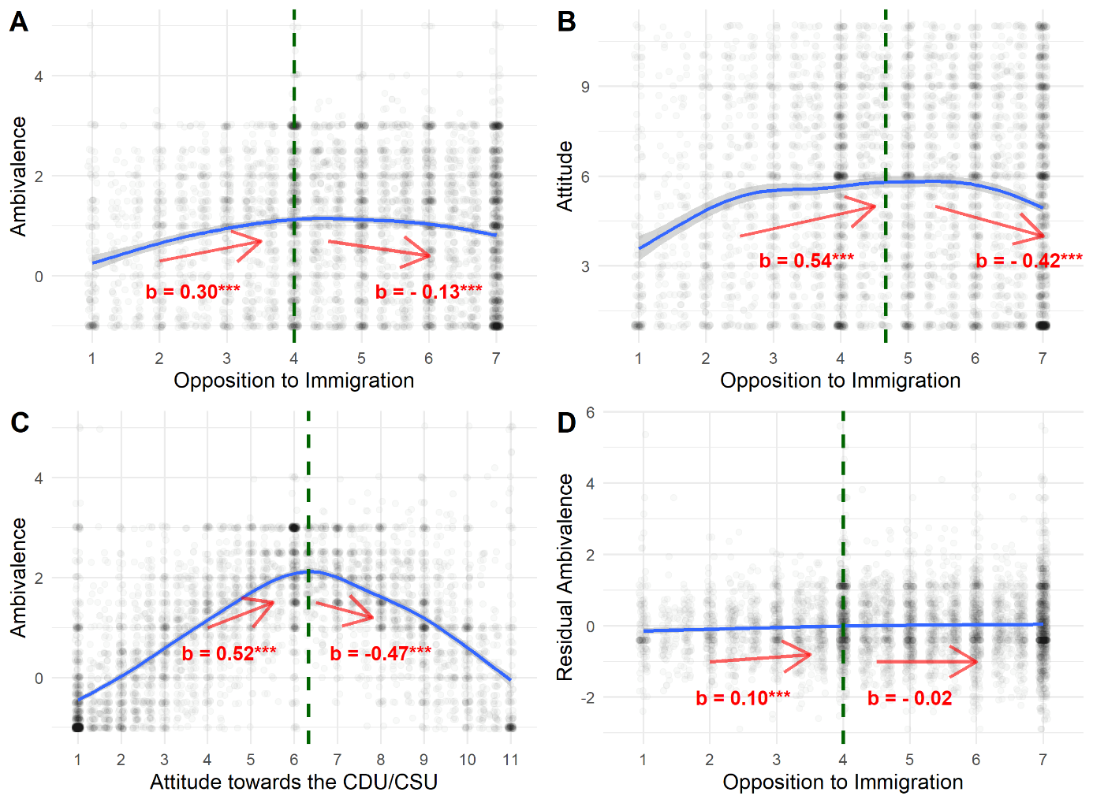

*Note.* The dashed vertical line represents the break point and the arrows and regression weights, refer to the regression lines below and above the break point of a two-lines test according to the algorithm developed by Simonsohn (2018). *** indicates p < .0001, ** indicates p < .001, * indicates p < .05.

**Figure A17**

*The association of affective ambivalence and the general attitude toward the CDU with economic ideology*

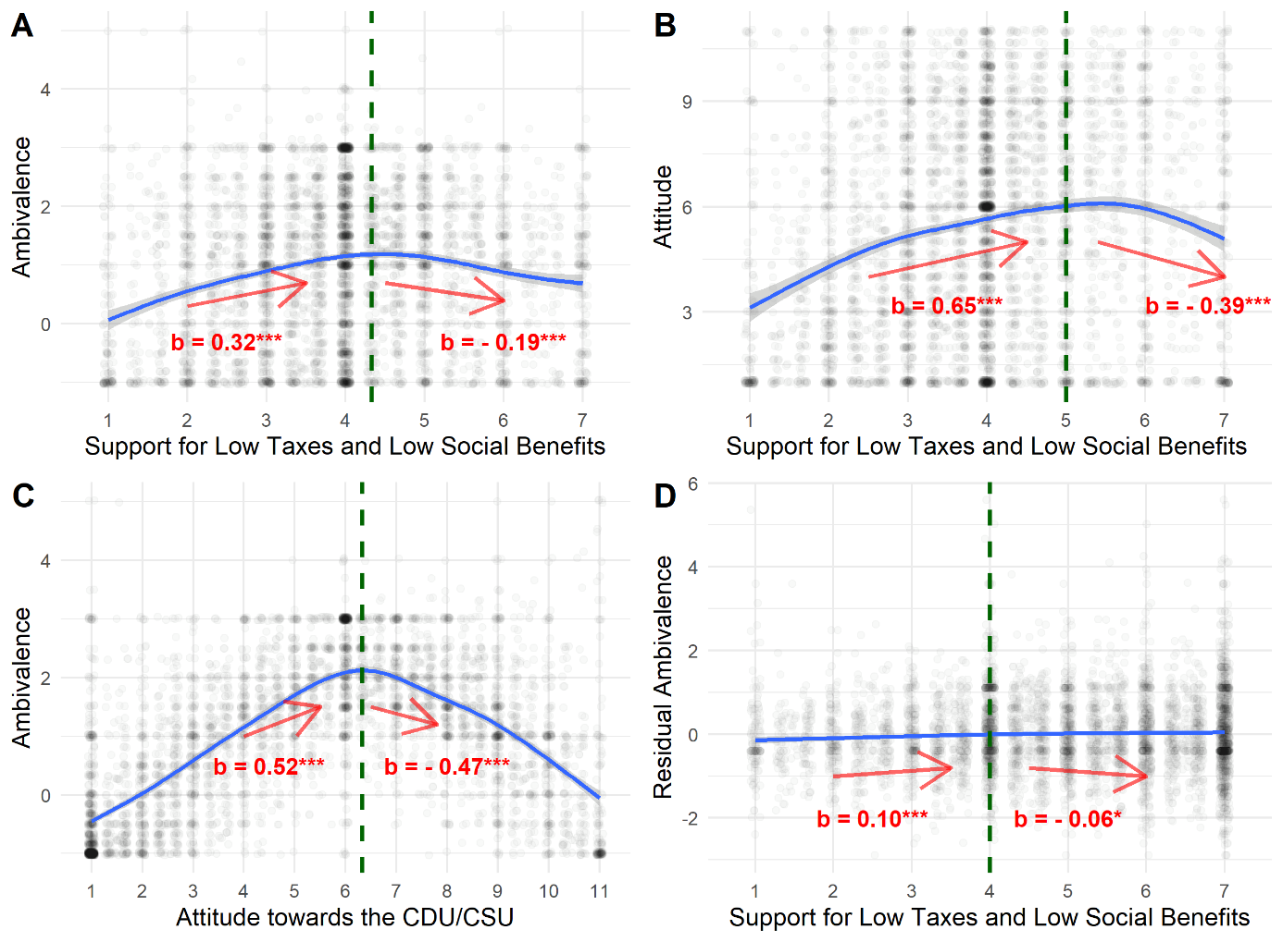

*Note.* The dashed vertical line represents the break point and the arrows and regression weights, refer to the regression lines below and above the break point of a two-lines test according to the algorithm developed by Simonsohn (2018). *** indicates p < .0001, ** indicates p < .001, * indicates p < .05.

**Figure A18**

*The association of affective ambivalence and the general attitude toward the SPD with social ideology*

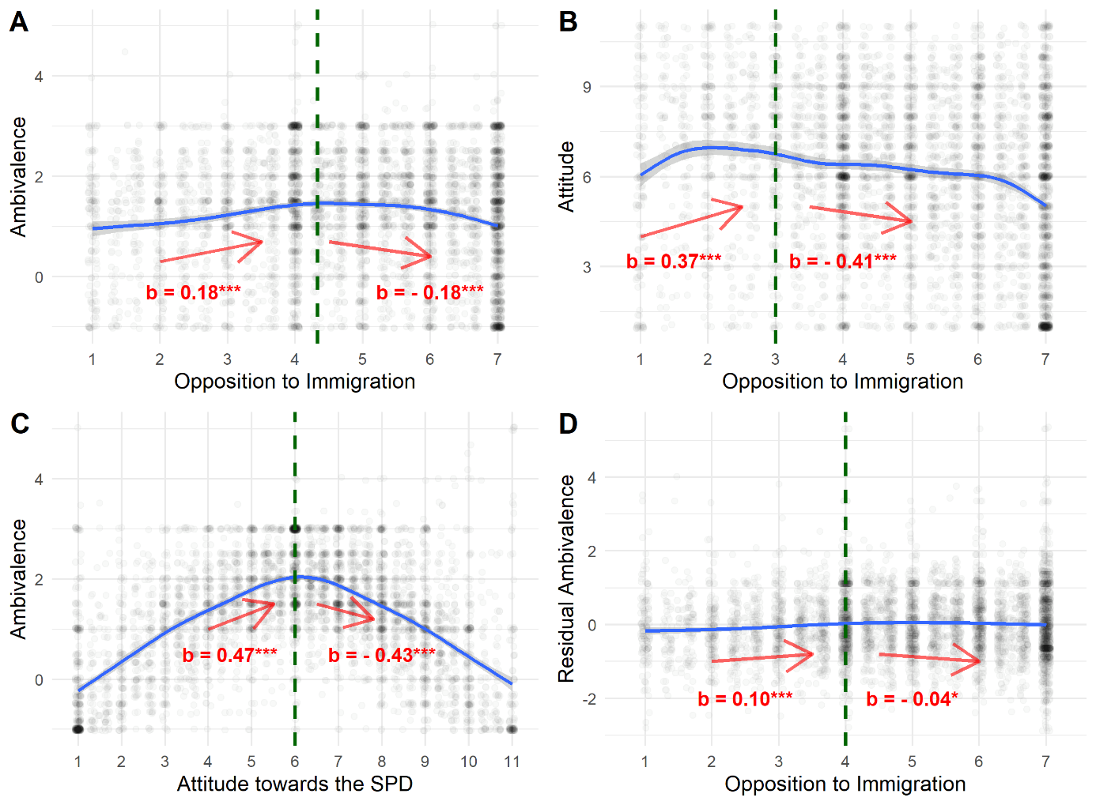

*Note.* The dashed vertical line represents the break point and the arrows and regression weights, refer to the regression lines below and above the break point of a two-lines test according to the algorithm developed by Simonsohn (2018). *** indicates p < .0001, ** indicates p < .001, * indicates p < .05.

**Figure A19**

*The association of affective ambivalence and the general attitude toward the SPD with economic ideology*

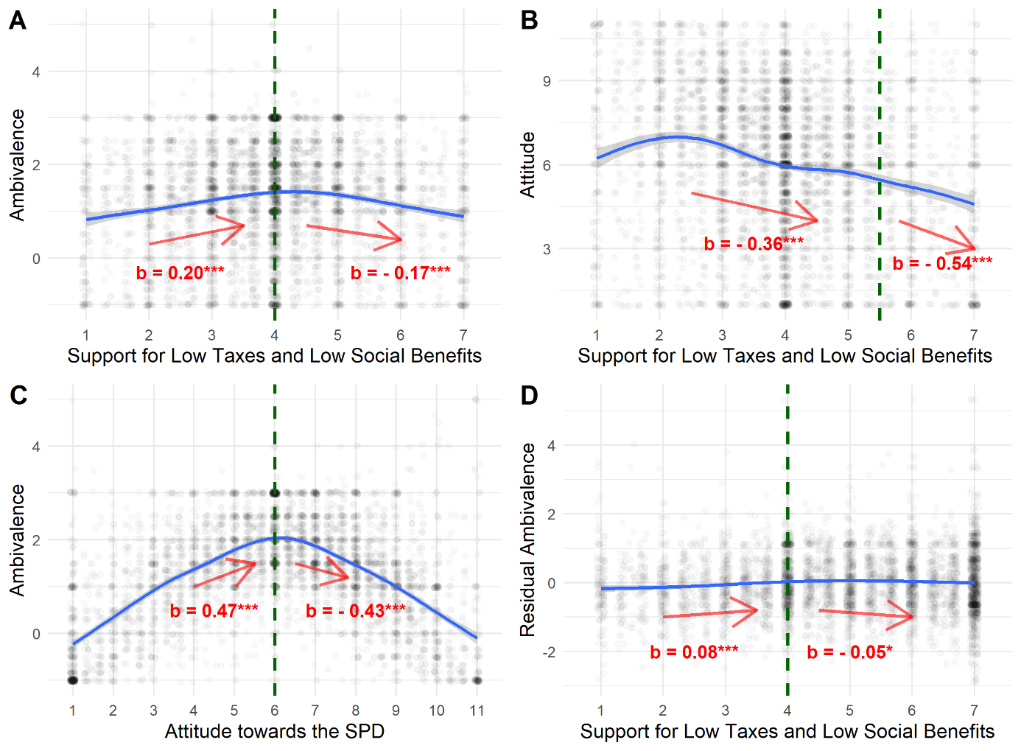

*Note.* The dashed vertical line represents the break point and the arrows and regression weights, refer to the regression lines below and above the break point of a two-lines test according to the algorithm developed by Simonsohn (2018). *** indicates p < .0001, ** indicates p < .001, * indicates p < .05.

**Figure A20**

*The association of affective ambivalence and the general attitude toward the FDP with social ideology*

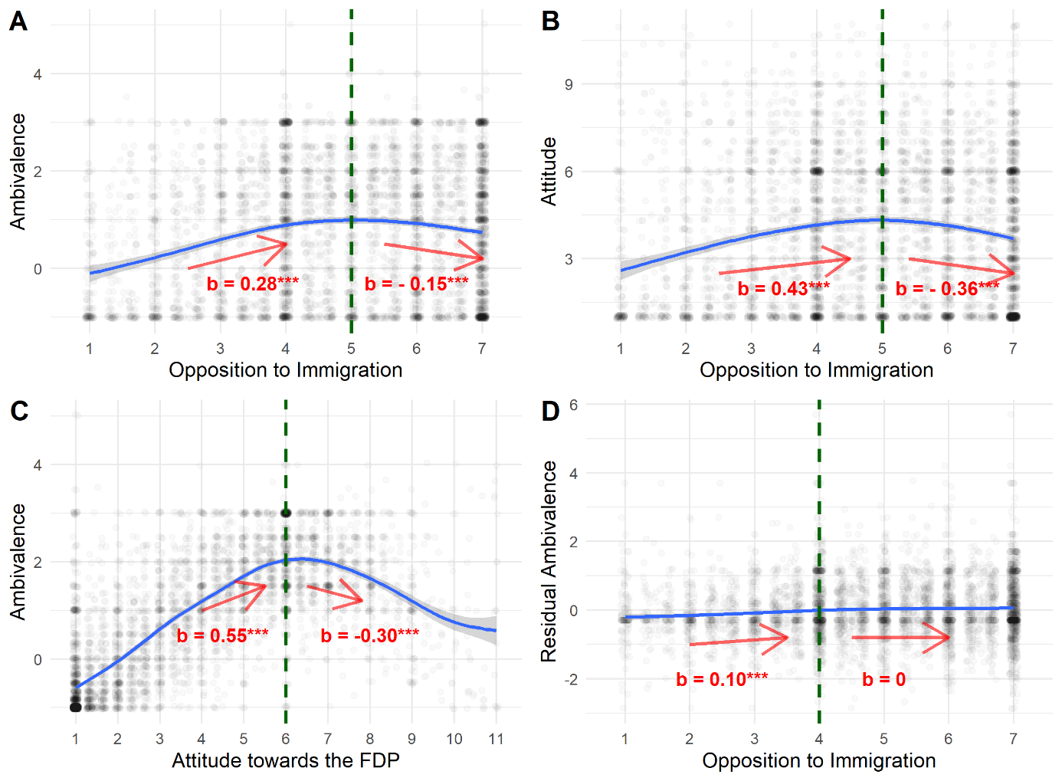

*Note.* The dashed vertical line represents the break point and the arrows and regression weights, refer to the regression lines below and above the break point of a two-lines test according to the algorithm developed by Simonsohn (2018). *** indicates p < .0001, ** indicates p < .001, * indicates p < .05.

**Figure A21**

*The association of affective ambivalence and the general attitude toward the FDP with economic ideology*

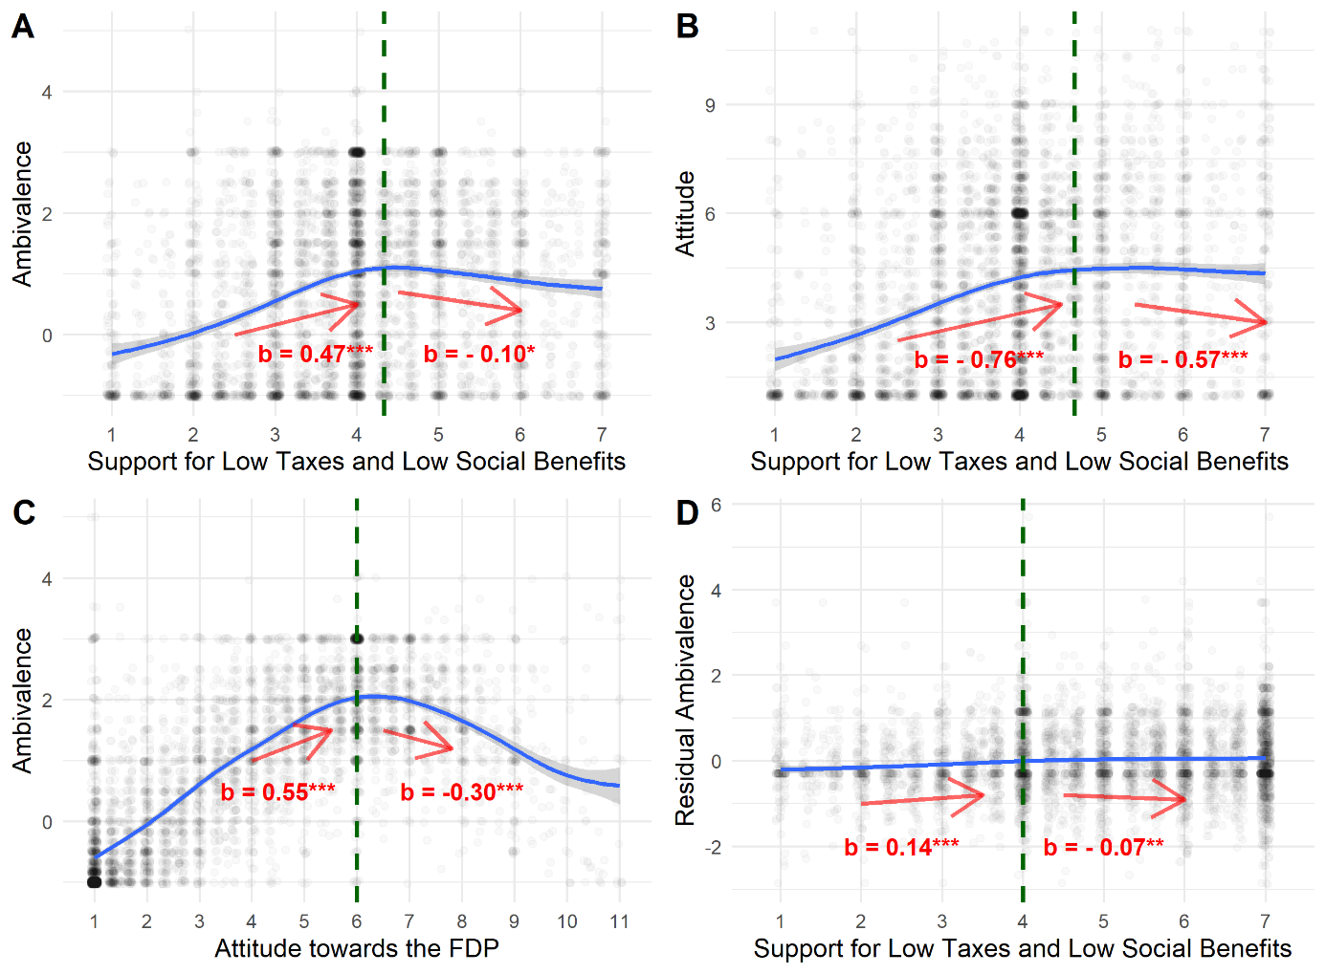

*Note.* The dashed vertical line represents the break point and the arrows and regression weights, refer to the regression lines below and above the break point of a two-lines test according to the algorithm developed by Simonsohn (2018). *** indicates p < .0001, ** indicates p < .001, * indicates p < .05.

**Figure A22**

*The association of affective ambivalence and the general attitude toward the GREEN party with social ideology*

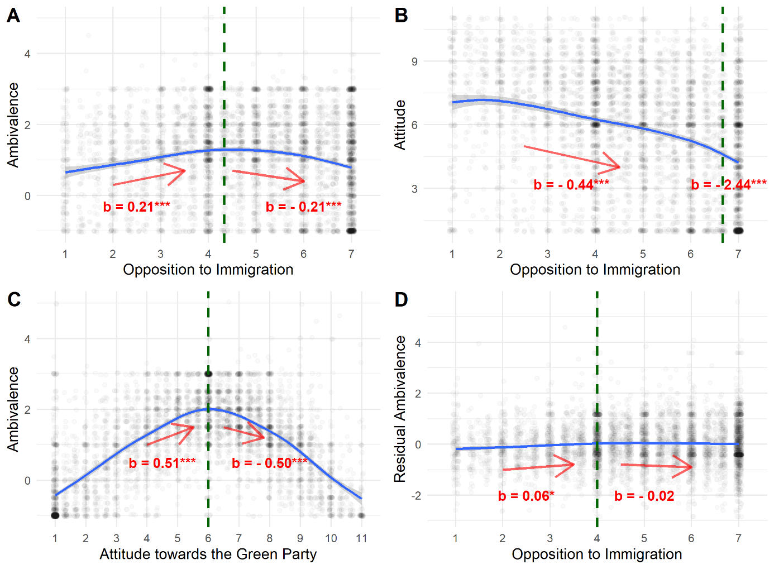

*Note.* The dashed vertical line represents the break point and the arrows and regression weights, refer to the regression lines below and above the break point of a two-lines test according to the algorithm developed by Simonsohn (2018). *** indicates p < .0001, ** indicates p < .001, * indicates p < .05.

**Figure A23**

*The association of affective ambivalence and the general attitude toward the GREEN party with economic ideology*

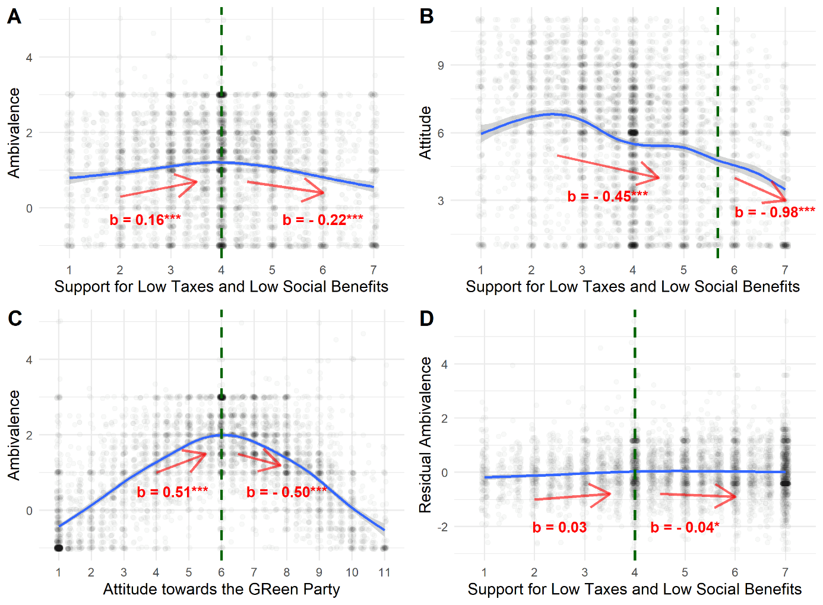

*Note.* The dashed vertical line represents the break point and the arrows and regression weights, refer to the regression lines below and above the break point of a two-lines test according to the algorithm developed by Simonsohn (2018). *** indicates p < .0001, ** indicates p < .001, * indicates p < .05.

**Figure A24**

*The association of affective ambivalence and the general attitude toward Die LINKE with social ideology*

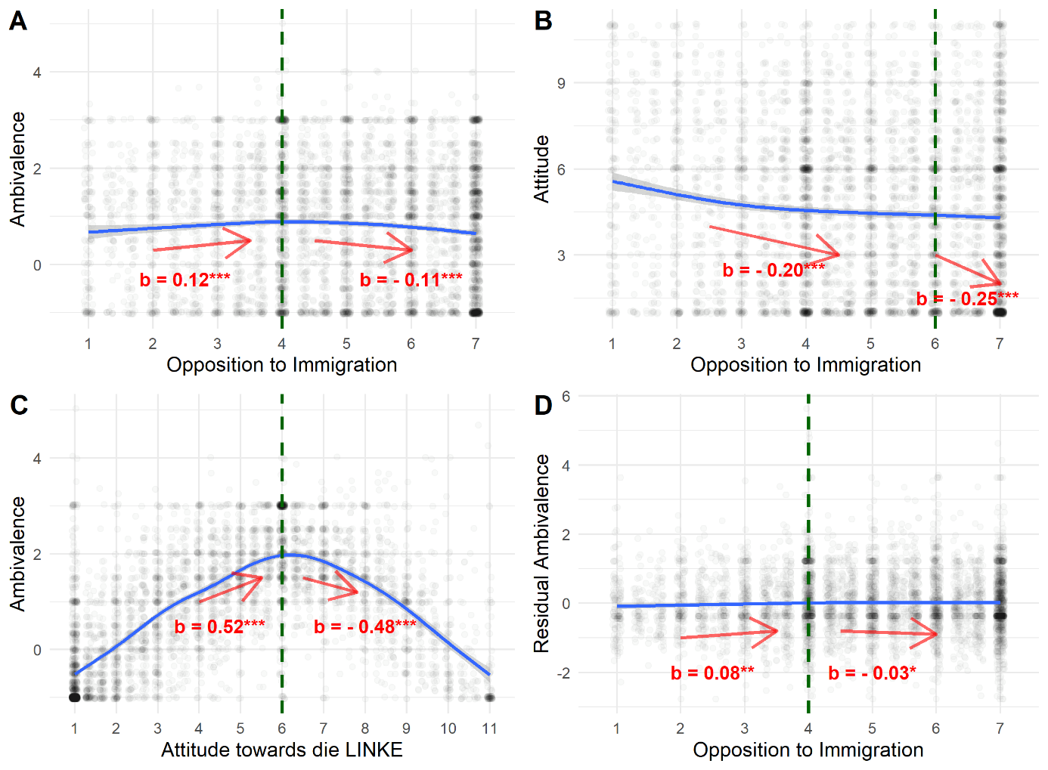

*Note.* The dashed vertical line represents the break point and the arrows and regression weights, refer to the regression lines below and above the break point of a two-lines test according to the algorithm developed by Simonsohn (2018). *** indicates p < .0001, ** indicates p < .001, * indicates p < .05.

**Figure A25**

*The association of affective ambivalence and the general attitude toward Die LINKE with economic ideology*

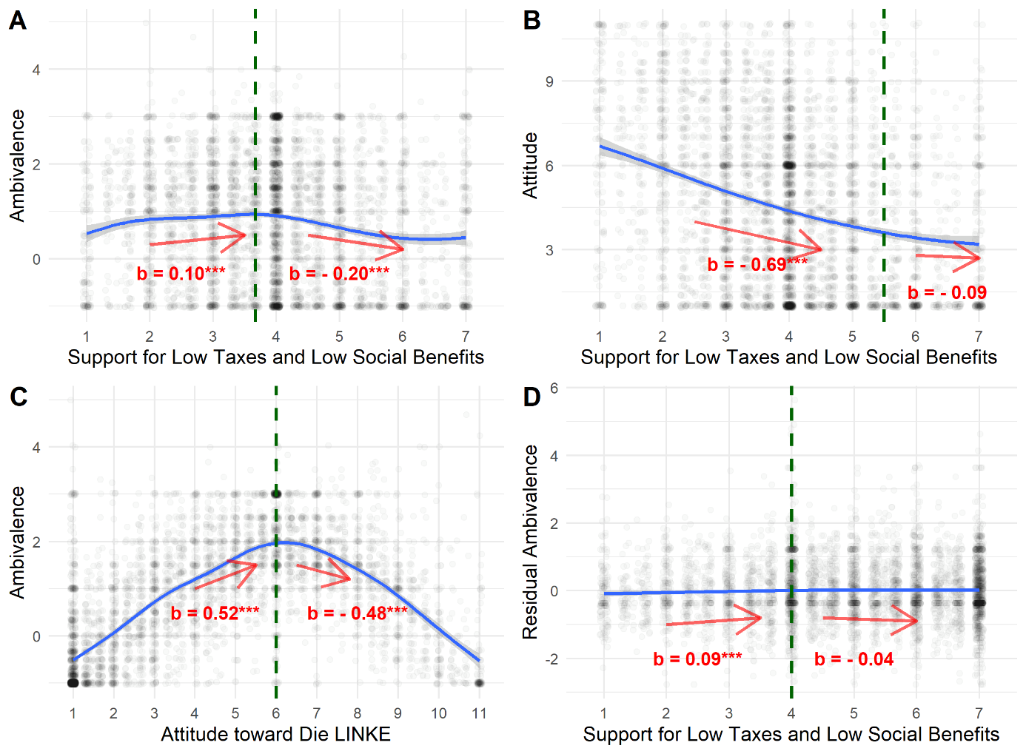

*Note.* The dashed vertical line represents the break point and the arrows and regression weights, refer to the regression lines below and above the break point of a two-lines test according to the algorithm developed by Simonsohn (2018). *** indicates p < .0001, ** indicates p < .001, * indicates p < .05.

# **4. References**

Diedenhofen, B., & Musch, J. (2015). cocor: A Comprehensive Solution for the Statistical Comparison of Correlations. *PLOS ONE*, *10*(4), e0121945. https://doi.org/10.1371/journal.pone.0121945

Lüdecke, D. (2021). *_sjPlot: Data Visualization for Statistics in Social Science_* (2.8.9). https://CRAN.R-project.org/package=sjPlot

Simonsohn, U. (2018). Two Lines: A Valid Alternative to the Invalid Testing of U-Shaped Relationships With Quadratic Regressions. *Advances in Methods and Practices in Psychological Science*, *1*(4), 538–555. https://doi.org/10.1177/2515245918805755

Stanley, D. (2021). *apaTables: Create American Psychological Association (APA) Style Tables* (2.0.8). https://CRAN.R-project.org/package=apaTables